20MCA136 – NETWORKING & SYSTEM ADMINISTRATION LAB Dept. of Computer Applications

|  |
| --- |
| **Name: VYSHNAV SURESH**  **Roll No: 56**  **Batch: B**  **Date: 05-05-2022** |

**NETWORKING & SYSTEM ADMINISTRATION LAB**

**Experiment No.: 9**

**Aim**

Write a shell script to find sum of two numbers.

# Program

echo "Enter the value of a” read a; echo "enter the value of b" read b; sum=$(($a+$b)) echo "the sum of" $a "and" $b "is: " $sum

# Output Screenshot

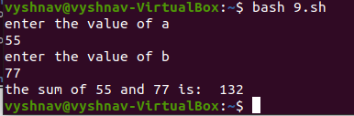

Amal Jyothi College of Engineering, Kanjirappally